H.T No
Regulations:
A20

Sreenidhi Institute of Science and Technology
(An Autonomous Institution)
Code No: 8K301 Date: 02-Sept-2023 (FN)

B.Tech II-Year I- Semester External Examination, Aug/Sept - 2023 (Supplementary)
SOLID MECHANICS (CIVIL)

Time: 3 Hours Max.Marks:70

Note: a) No additional answer sheets will be provided.
b) All sub-parts of a question must be answered at one place only, otherwise it will not be valued.
c) Missing data can be assumed suitably.

Bloom's Cognitive Levels of Learning (BCLL)

Remember | L1 | Apply | L3 | Evaluate | L5
Understand | L2 | Analyze | L4 | Create | L6

Part - A Max.Marks:20
Answer all QUESTIONS

 |  | BCLL | CO(s) | Marks
1 | Define Elasticity and state Hooke’s Law. | L2 | CO1 | [2M]
2 | Define shear force and bending moment. | L2 | CO2 | [2M]
3 | What is meant by moment of resistance? | L1 | CO3 | [2M]
4 | State Mohr’s theorems for finding slope and deflection of beams. | L1 | CO4 | [2M]
5 | Define the terms : Principal planes and principal stresses. | L2 | CO5 | [2M]
6 | Sketch the typical shear stress distribution for “T” section? | L2 | CO6 | [2M]
7 | Define the following properties of engineering materials:  (i) Ductility (ii) Brittleness | L2 | CO1 | [2M]
8 | Define the terms: bending stress in a beam, neutral axis. | L2 | CO3 | [2M]
9 | What do you mean by shear stresses in beams? | L1 | CO6 | [2M]
10 | Differentiate between a fixed beam and a cantilever. | L2 | CO2 | [2M]
Part – B Max.Marks:50
ANSWER ANY FIVE QUESTIONS. EACH QUESTION CARRIES 10 MARKS.

 |  |  | BCLL | CO(s) | Marks
11. |  | A bar of 20mm diameter subjected to pull of 50kN. The measured extension of guage length of 250mm is0.12mm and change in diameter is 0.00375mm. calculate Young’s modulus, Poisson’s ratio and bulk Modulus | L3 | CO1 | [10M]
12. |  | Draw the shear force and bending moment diagram for the simply supported beam shown in the figure.  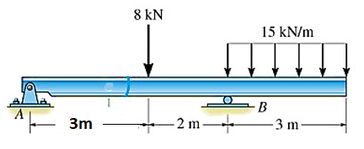 | L3 | CO2 | [10M]
13. |  | Derive the ‘bending equation’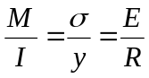 for calculation of bending stress in beams. State the assumptions in the theory of bending. | L4 | CO3 | [10M]
14. |  | Determine the slope at both the supports and maximum deflection using Macaulay’s method. Take E = 2.1 x 10⁵ N/mm² and I = 8 x 10⁸ mm⁴.  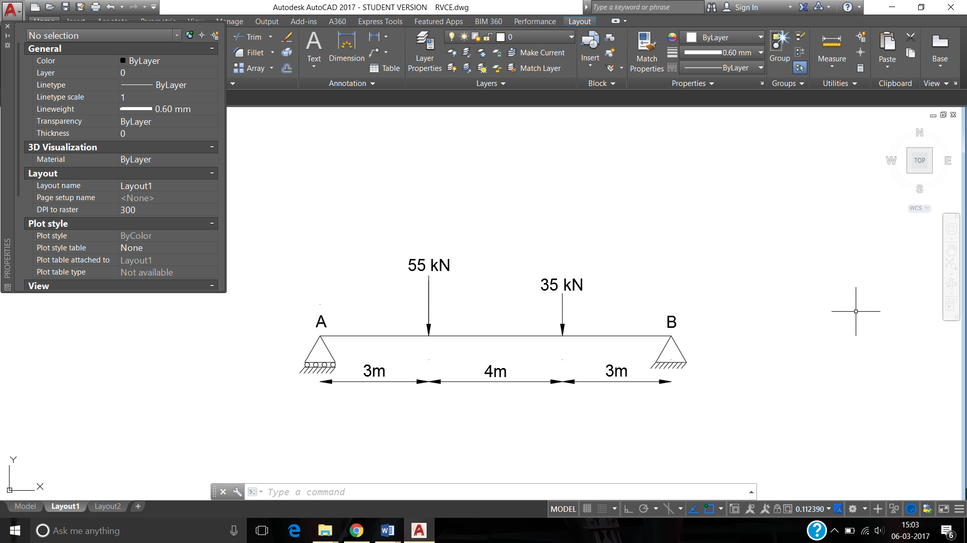 | L4 | CO4 | [10M]
15. |  | At a point in a strained material, there are normal stresses of 60 Mpa (Compressive) and 40Mpa (Tensile) at right angles to each other with a shear stress 20MPa (negative). Determine the principal stresses, maximum shear stress and plane on which they act. Show them on the sketches of properly oriented elements. Use Mohr’s circle method. | L4 | CO5 | [10M]
16. |  | Discuss in detail various Theories of failure and give the application of each of them. | L4 | CO6 | [10M]
17. | a) | A brass bar having a cross sectional area of 1000 mm² is subjected to axial forces as shown in Fig.1 Find the total change in length of the bar. Assume E_{b}=100 GPa.  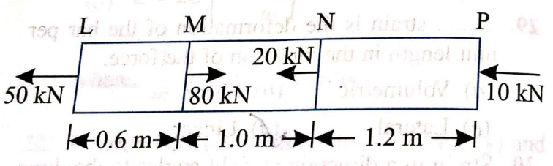 | L3 | CO1 | [4M]
 | b) | Sketch any three deflected shapes of beams with different support conditions | L3 | CO2 | [3M]
 | c) | Define section modulus and write the expression. | L2 | CO3 | [3M]
18. | a) | Determine the maximum deflection of a simply supported beam having length ‘l’ and point load W at the center using double integration method | L2 | CO4 | [5M]
 | b) | A wooden beam 100 mm wide and 150 mm deep is simply supported overa span of 4 metres. If shear force at a section of the beam is 4500 N, find the shear stress at a  distance of 25 mm above the N.A.  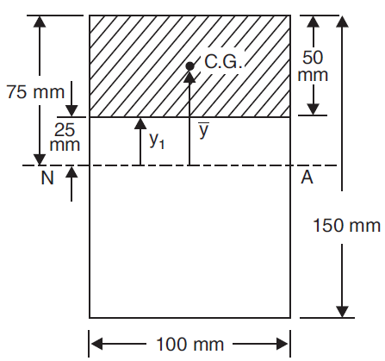 | L4 | CO5 | [5M]

-- 00 -- 00 –

